User’s Guide
Editor: WANG Hongxuan

Application Overview
This application is a spotlight model management tool that allows users to:
- Create and manage spotlight models with specific parameters.
- Export presets to Excel or modify presets from Excel data.
- Perform error corrections on presets using provided parameters.
The application includes a graphical user interface (GUI) implemented with PySide6 and provides functionality across multiple tabs for different tasks.

Features

1. Manage Spotlight Models
- Create New Models: Add a new spotlight model with custom parameters (a, b, c, d).
- Load Models: Select and view pre-defined models from a JSON file.
- Save Models: Persist created models into the JSON file for future use.

2. Preset and Excel Management
- Presets to Excel: Export preset data into Excel files.
- Excel to Presets: Modify presets using data from Excel files.

3. Error Correction
- Apply corrections to presets based on specific parameters and input files.

Getting Started

System Requirements
- Python 3.8 or higher
- PySide6 installed (pip install PySide6)
- Necessary Python libraries: numpy, pandas, openpyxl, scipy, qt_material

Launching the Application
Two ways:
  - Run the main script to launch the GUI:
python ui_start.py
  - Launch the PresetsCorrection.exe (on Windows system)

Interface Guide

Main Tabs
- Select Model Tab
  - Purpose: Choose a spotlight model or create a new one.
  - Key Elements:
    - Dropdown (comboBox): Select a spotlight model.
    - Parameters (a, b, c, d): View model parameters.
    - Buttons:
      - Create a New Model: Opens a dialog to add a new model.
      - Select: Proceeds to the next tab.
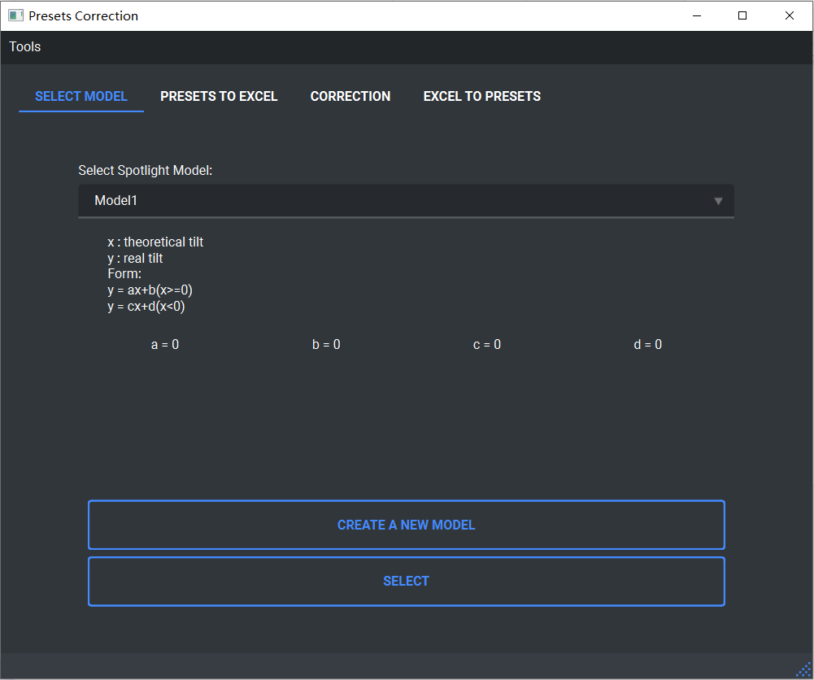
- Presets to Excel Tab
  - Purpose: Export preset data into an Excel file.
  - Key Elements:
    - Input fields:
      - Presets Folder Path: All the presets(xml) in this folder will be read
      - Excel Export Path: The path to export the Excel
    - Button:
      - Export: Saves the preset data to the specified Excel file.
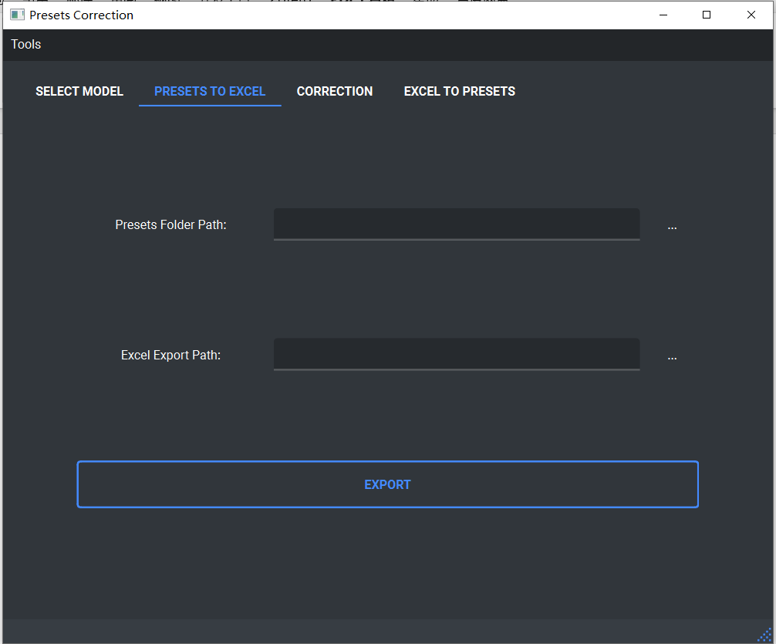
- Correction Tab
  - Purpose: Correct preset data using specific parameters.
  - Key Elements:
    - Input fields:
      - Config Path: The path of the configuration Excel (See ExcelExamples for the detail form)
      - Excel_M Path: The path of measuring data Excel (This Excel is exported by reading the measuring presets)
      - Excel_C Path: The path of to-change-presets Excel (This Excel is exported by reading the presets which are needed to correct)
    - Dropdown (comboBox): Select the number of sensors.
    - Button:
      - Correct: Applies corrections to the presets.

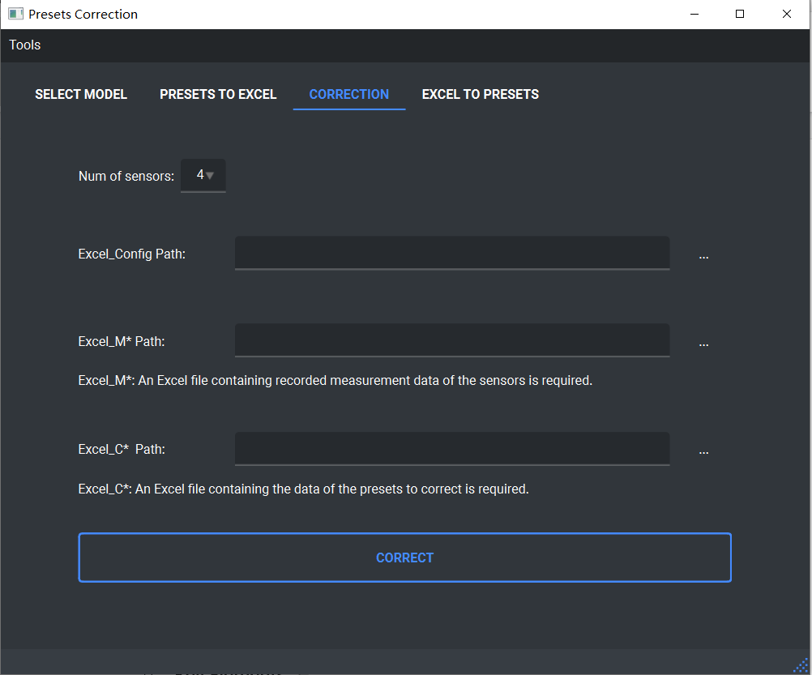
- Excel to Presets Tab
  - Purpose: Modify presets using Excel data.
  - Key Elements:
    - Input fields:
      - Excel Path: The path of the Excel which contains the right data for the to-change-presets.
      - Presets Folder Path: The path of the folder which contains the to-change-presets.
    - Button:
      - Export: Modifies presets based on Excel data.
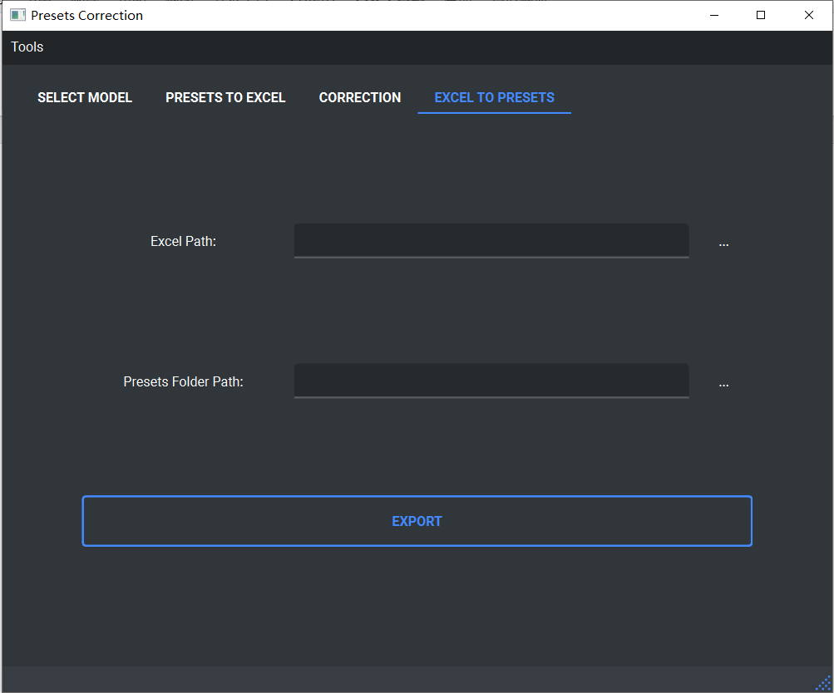

Use Guide

Select a model
Page: Select Model
- Loading Models
  - Select a model from the dropdown.
  - View parameters in the displayed fields.
- Click Select

(Optional)

Creating a New Model
- Click Create a New Model.
- Enter:
  - Model Name.
  - Parameters (a, b, c, d).
- Click OK to save or Cancel to discard.
- The new model will appear in the dropdown.

Saving Models
- Models are automatically saved to data/data.json.

Read the measuring presets
Page: Presets to Excel
- Specify the Presets Folder Path.
- Specify the Excel Export Path.
- Click Export.
In this step, “the measuring presets” means the presets which contains the pans/tilts when they pointing to the sensors.

Read the show presets
Page: Presets to Excel
- Specify the Presets Folder Path.
- Specify the Excel Export Path.
- Click Export.
In this step, “the show presets” means the presets which need to be corrected.
In this step, “the measuring presets” means the presets which contains the pans/tilts when they pointing to the sensors.

Set the configuration
In this step, you need to specify the positions of the sensors and the theoretical positions of the spotlights in Excel “config.xlsx”.
The form of this Excel is in the folder “/ExcelExamples”.

Select the number of sensors
Page: Correction
In this step, you need to choose the number of sensors. The program can calculate the error by using 4 or 5 sensors (affect accuracy).

Select Excels and correct
Page: Correction
  - Specify:
  - Config Path: Excel file set in step 4 (config.xlsx).
  - Excel_M Path: Excel file exported in step 2.
  - Excel_C Path: Excel file exported in step 3.
  - Click Correct to apply corrections.
The program will export an Excel file named <Excel_C file name>_change.xlsx which contains the right pans/tilts of the show presets in the same folder as the Excel_C.

Apply correction
Page: Excel To Presets
- Specify path of <Excel_C file name>_change.xlsx.
- Specify the Presets Folder Path.
- Click Export to modify presets.
The program will copy these presets and apply the right values in Excel. The corrected presets will be placed in a folder named “presets_change”.
This manual provides a comprehensive overview of the functionality and usage of the application. If you encounter issues, ensure all paths and files are correctly specified and match the required formats.

